Link: <http://www.studytonight.com/computer-networks/bounded-transmission-media>

Under : Bounded/Guided Media

**Replace given text by this:**

Guided media, which are those that provide a conduit from one device to another, **include twisted-pair cable, coaxial cable,** and **fibre-optic cable**.

A signal travelling along any of these media is directed and contained by the physical limits of the medium. Twisted-pair and coaxial cable use metallic (copper) conductors that accept and transport signals in the form of electric current. **Optical fibre** is a cable that accepts and transports signals in the form of light.

**Under** : Twisted-Pair Cable: **Before** the line : Twisted Pair is of two types

**Add this:**

A twisted pair consists of two conductors (normally copper), each with its own plastic insulation, twisted together.

One of these wires is used to carry signals to the receiver, and the other is used only as ground reference. The receiver uses the difference between the two.

In addition to the signal sent by the sender on one of the wires, interference (noise) and crosstalk may affect both wires and create unwanted signals.

If the two wires are parallel, the effect of these unwanted signals is not the same in both wires because they are at different locations relative to the noise or crosstalk sources. This results in a difference at the receiver.

**After** : Disadvantages of shielded twisted pair cable:

**Add the following :**

**Performance**:

One way to measure the performance of twisted-pair cable is to compare attenuation versus frequency and distance. As shown in the below figure, a twisted-pair cable can pass a wide range of frequencies. However, with increasing frequency, the attenuation, measured in decibels per kilometre (**dB/km**), sharply increases with frequencies above 100kHz. Note that **gauge** is a measure of the thickness of the wire.

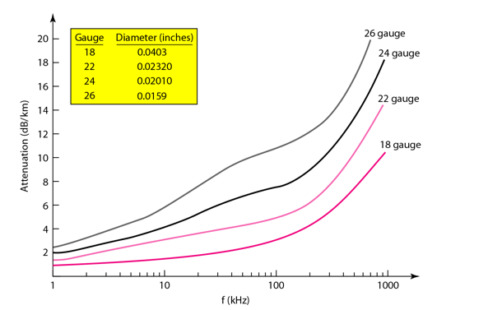

**Applications**:

* In **telephone lines** to provide voice and data channels. The DSL lines that are used by the telephone companies to provide high-data-rate connections also use the high-bandwidth capability of unshielded twisted-pair cables.
* **Local Area Network**, such as 10Base-T and 100Base-T, also use twisted-pair cables.

**Rest is fine under Twisted Pair Cable**